PROJECT TITLE | :CUSTOMER SUPPORT TICKET PRIORITY PREDICTION AND AUTOMATED ASSIGNMENT SYSTEM USING AGENTFORCE
COLLEGE NAME | ARASU ENGINEERING COLLEGE,  KUMBAKONAM
TEAM LEADER  (WITH EMAIL ID) | : KRUBALAKSHMI KS  (sureshkruba438@gmail.com)
TEAM MEMBER 1  (WITH EMAIL ID) | : AADHI P  (rajinipandiyan74@gmail.com)
TEAM MEMBER 2  (WITH EMAIL ID) | : ARULMOZHI G  (arulsivan2005@gmail.com)
TEAM MEMBER 3  (WITH EMAIL ID) | : FARHATH ZAFIN M  (rafiqzafin@gmail.com)
TEAM MEMBER 4  (WITH EMAIL ID) | : AKSHAYA E  (akshaya.elangovan2k@gmail.com)
CUSTOMER SUPPORT TICKET PRIORITY PREDICTION AND AUTOMATED ASSIGNMENT SYSTEM USING AGENTFORCE
SALESFORCE IMPLEMENTATION

User Story:
The Customer Support Ticket Priority Prediction and Automated Assignment System is a Salesforce solution that reads the description of a customer support ticket, decides whether its priority is High, Medium or Low, and starts the right backend automation. Support tickets are stored in the Support Ticket Intelligence custom object and are linked to Accounts and Contacts. An Auto-Launched Flow retrieves the latest ticket of an account, analyzes its description, sets the priority and, for High-priority tickets, creates an urgent handling task and assigns a senior support agent. An Agentforce subagent named Support Ticket Priority Analysis lets support users run this process through a simple conversation by giving an Account Name. Together, these features reduce manual triage, improve response time and give the support team clearer control over urgent issues.

1. INTRODUCTION

1.1 Project Overview
Customer support teams receive many tickets every day through email, web forms and chat. In many organizations, prioritizing and assigning these tickets is done by hand, which is slow, inconsistent and can hide urgent problems behind routine requests. This project provides a Salesforce-based solution that analyzes ticket information, classifies urgency, assigns the appropriate support level and starts automation for critical cases.
The solution models the business with one custom object (Support Ticket Intelligence) connected to the standard Account, Contact, User and Task objects. A record-triggered style logic is implemented in an Auto-Launched Flow, and Agentforce provides the conversational front end. The complete solution was configured and tested in a Salesforce Developer Edition org for academic purposes, following the practices of a real implementation.

1.2 Purpose
The system exists to make ticket handling faster, more consistent and easier to monitor. Specifically, it is designed to:
- Automatically classify support tickets as High, Medium or Low priority.
- Retrieve the latest support ticket associated with a customer Account.
- Reduce the manual effort of prioritizing and assigning tickets.
- Create an urgent handling task for High-priority tickets.
- Use Agentforce to analyze ticket details and trigger backend automation.
- Improve ticket response and resolution efficiency.

1.3 Objectives and Business Value
The main objective is to give the support team a single, reliable and automated way to decide which tickets need attention first. The business value comes from:
- Less manual work: priority setting, task creation and assignment run automatically.
- Faster response: critical tickets are identified from their description without waiting for a person to read them.
- Better assignment: urgent tickets reach a senior support agent.
- Visibility: agents and managers can see ticket status, priority and SLA risk.
- Easy access: support users get a clear answer by chatting with Agentforce.

2. IDEATION PHASE

2.1 Problem Statement (Customer Problem Statement Template)
PS | I am (Customer) | I'm trying to | But | Because | Which makes me feel
PS-1 | Support Agent | focus on critical tickets first | tickets are not always prioritized automatically | prioritization can be manual | frustrated
PS-2 | Customer | get urgent issues resolved quickly | critical issues may wait behind lower-priority tickets | support teams handle large ticket volumes | concerned
PS-3 | Support Manager | assign tickets to the right support level | assignment may need manual decisions | ticket urgency is not consistently analyzed | overwhelmed
PS-4 | Support Agent | identify urgent issues from descriptions | important keywords can be missed | descriptions contain different urgency signals | uncertain
PS-5 | Support Manager | reduce SLA-related risk | older unresolved tickets may go unnoticed | SLA risk needs additional checking | concerned

2.2 Empathy Map Canvas
User Persona: Support Agent
Primary responsibility: reviewing customer tickets, handling assigned cases and focusing on urgent issues.
Quadrant | Description
Think & Feel | Wants critical issues identified quickly so urgent customer problems receive attention.
Hear | Customer issue descriptions and support requests.
See | Ticket status, issue type, description, priority level, assignment and SLA risk.
Say & Do | Reviews tickets, handles assigned cases and focuses on urgent support issues.
Pain | Manual prioritization, missed urgency signals and delays in handling critical tickets.
Gain | Automatic priority classification, clearer assignment, urgent task creation and reduced manual effort.

2.3 Brainstorming and Idea Prioritization
Ideas Considered
Idea | Approach | Key Limitation
Manual ticket registers | Record ticket details on paper or in notebooks | Slow, error-prone and hard to track
Spreadsheet tracking | Track tickets in spreadsheets | Little automation and no AI support
Standalone support portal | Build a dedicated support portal | High development and maintenance effort
Salesforce CRM with Agentforce | Centralize tickets, automation and AI on Salesforce | Needs careful configuration

Final Selection: Salesforce CRM with Agentforce was selected for these reasons:
- Automation: Flow automates priority setting, task creation and assignment.
- AI assistance: Agentforce analyzes ticket details through conversation.
- Scalability: The platform grows with more tickets, users and requirements.

3. REQUIREMENT ANALYSIS PHASE

3.1 Customer Journey Map
Stage | Journey Stage | What Happens
1 | Raise Ticket | The customer reports an issue through a support channel.
2 | Ticket Received | The ticket is stored in the Support Ticket Intelligence object.
3 | AI Analysis and Prioritization | Agentforce and the Flow read the description and classify priority.
4 | Auto Assignment | The ticket is assigned to the right support level.
5 | Urgent Task Creation | High-priority tickets get an Urgent Ticket Handling task.
6 | Agent Works on Ticket | The agent investigates, updates the status and resolves the issue.
7 | Customer Gets Updates | The customer is informed about progress and resolution.
8 | Feedback and Improvement | Feedback and ticket data are used for continuous improvement.

3.2 Solution Requirements
Functional Requirements
FR No | Requirement
FR-1 | Support ticket creation and management
FR-2 | Account and Contact association
FR-3 | Ticket description analysis
FR-4 | Automatic priority classification
FR-5 | High-priority task creation
FR-6 | Support agent assignment
FR-7 | SLA breach risk checking
FR-8 | Agentforce conversational analysis

Non-Functional Requirements
NFR | Description
Usability | Clear Agentforce interaction and understandable priority messages.
Reliability | Consistent priority classification based on configured conditions.
Performance | Quick retrieval and analysis of the latest support ticket.
Security | Controlled Salesforce access to customer and ticket information.
Maintainability | Flow and Agentforce configuration can be updated easily.
Scalability | Supports growing ticket volumes through Salesforce automation.

3.3 Data Flow Diagram
Main Flow
Customer or Support User → Account Name → Salesforce Agentforce → Support Ticket Priority Analysis subagent → Auto-Launched Flow → Account → Latest Support Ticket → Ticket Description → Analyze Description → Priority Level → High / Medium / Low decision → Agent Assignment → High-Priority Task (if applicable) → Final Response.
Supporting Flows
- Agentforce flow: Support user gives the Account Name → Agentforce calls the Flow → ticket analysis → priority and assignment output → response to the user.
- High-priority handling: Ticket priority is High → Create Task (Urgent Ticket Handling) → assign Senior Support Agent → urgent handling message.
- Medium and Low handling: Ticket is Medium or Low → priority is set → message says it will be handled shortly or is queued.
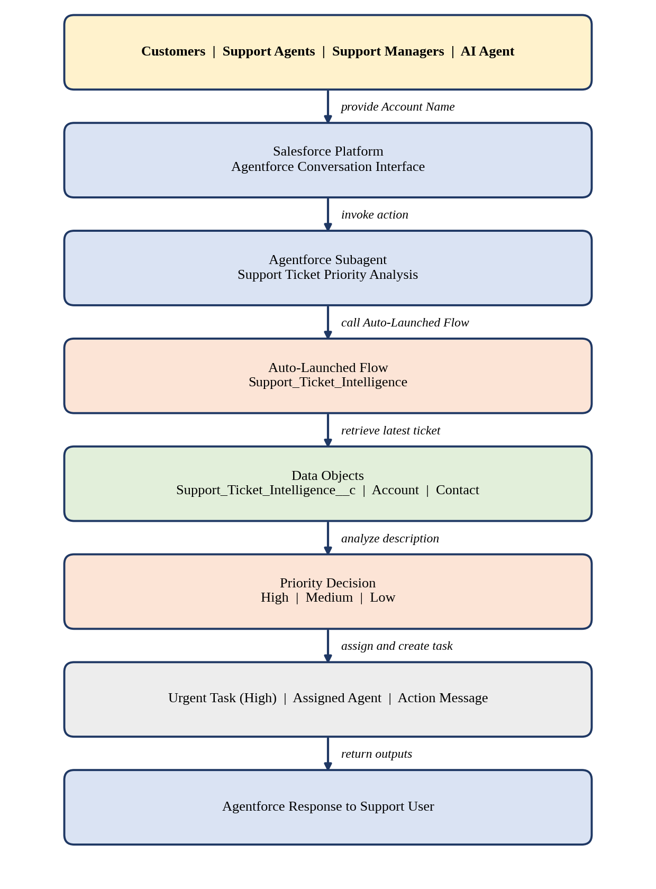
Figure 1: Data flow diagram of the Support Ticket Priority System

3.4 Technology Stack
Layer | Technology
Platform | Salesforce, Developer Edition
Database | Support_Ticket_Intelligence__c with Account, Contact, User and Task records
Logic | Auto-Launched Flow
AI | Agentforce
Agent Configuration | Support Ticket Priority Analysis subagent
Automation | Flow Decision, Assignment and Create Records
Security | Profiles, roles, permission sets, sharing settings, Einstein Trust Layer
Reporting | Reports and dashboards
Output | Agentforce conversation response

4. PROJECT DESIGN PHASE

4.1 Problem-Solution Fit
Each problem identified in the ideation phase is matched with a Salesforce capability in the table below.
Problem | Solution | Benefit
Manual ticket prioritization | Flow analyzes the description and sets priority | Faster identification of urgent cases
Urgent issues may be missed | Keyword-based High-priority decision | Critical cases receive attention
Manual task creation | Flow creates a Task for High priority | Reduced manual effort
Manual support assignment | Flow sets the assigned support level | More consistent handling
SLA risk can be overlooked | Optional SLA risk decision | Better risk awareness
Need for conversational access | Agentforce subagent | AI-assisted interaction

4.2 Proposed Solution
Parameter | Description
Problem | Manual ticket prioritization and assignment delay the handling of critical customer issues.
Solution | A Salesforce-based Customer Support Ticket Priority Prediction and Automated Assignment System.
Innovation | Agentforce AI with an Auto-Launched Flow that analyzes descriptions, classifies priority, assigns a support level and triggers urgent-task automation.
Impact | Faster identification of critical tickets, reduced manual effort, improved response time and better team productivity.
Business Model | Customer support operations involving customers, support agents, managers and AI-assisted ticket handling.
Scalability | Supports growing ticket volumes, with scope for more assignment rules, SLA monitoring and priority indicators.

4.3 Solution Architecture
The solution is made up of the following components:
- Custom object: Support Ticket Intelligence, with Account, Contact, User and Task records
- Auto-Launched Flow with decision, assignment and create-record elements
- Agentforce subagent and Flow-based agent action
- Profiles, roles, permission sets and sharing settings
- Lightning record page, reports and dashboard
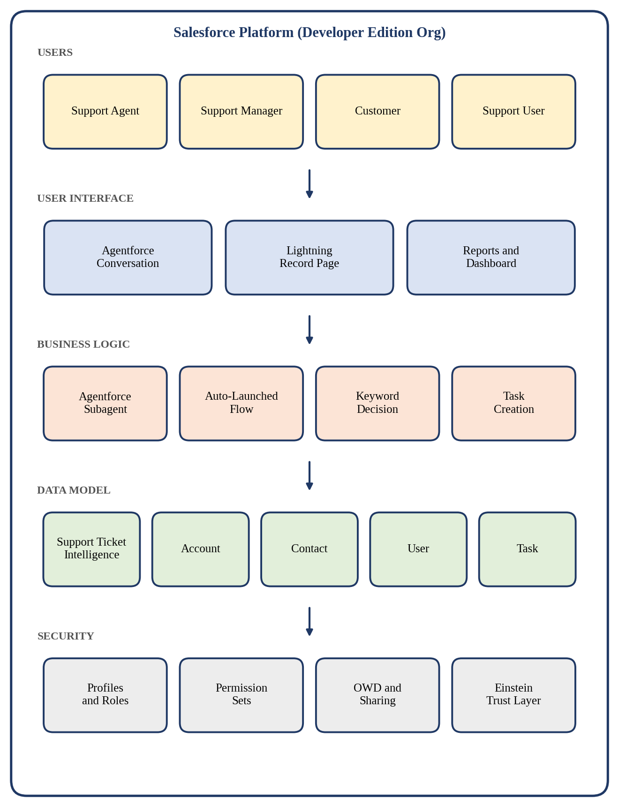
Figure 2: Solution architecture of the Support Ticket Priority System

5. PROJECT PLANNING AND SCHEDULING

5.1 Project Planning
The project followed an Agile approach: requirements were grouped into epics, split into user stories with story points, and delivered in six sprints. Velocity from each sprint was used to estimate the next.
Product Backlog and Sprint Schedule
Sprint | Epic | US No | User Story / Task | Points | Priority | Member
Sprint-1 | Developer Setup | US-01 | As a system administrator, I want to configure the Salesforce environment so that the solution can be developed. | 3 | High | Member 1
Sprint-2 | Data Modeling | US-02 | As an admin, I want to create the Support Ticket Intelligence object with fields and relationships so that tickets are stored systematically. | 5 | High | Member 2
Sprint-2 | Data Modeling | US-03 | As a support user, I want tickets linked to Accounts and Contacts so that the latest customer ticket can be identified. | 3 | High | Member 3
Sprint-3 | Automation | US-04 | As a support agent, I want a Flow to retrieve the latest ticket and analyze its description so that priority is determined automatically. | 5 | High | Member 4
Sprint-3 | Automation | US-05 | As a support agent, I want tickets classified as High, Medium or Low so that critical issues get attention first. | 5 | High | Member 4
Sprint-4 | Agentforce and Automation | US-06 | As an AI agent, I want to analyze ticket details and trigger the Flow so that manual prioritization is reduced. | 8 | High | Member 1
Sprint-4 | Task and Assignment | US-07 | As a support manager, I want High-priority tickets to create an urgent task and be assigned to the right level so that they are handled quickly. | 5 | High | Member 2
Sprint-5 | SLA Management | US-08 | As a support manager, I want SLA breach risk checked for older unresolved tickets so that issues are identified early. | 5 | Medium | Member 3
Sprint-6 | Agentforce and Conversational Support | US-09 | As a support user, I want to give an Account Name to Agentforce and receive the ticket ID, priority, assigned agent and action message. | 5 | Medium | Member 4

Project Tracker, Velocity and Burndown
Sprint | Total Points | Duration | Start Date (Planned) | End Date (Planned) | Points Completed | Release Date (Actual)
Sprint-1 | 3 | 6 days | DD Mon YYYY | DD Mon YYYY
Sprint-2 | 8 | 6 days | DD Mon YYYY | DD Mon YYYY
Sprint-3 | 10 | 6 days | DD Mon YYYY | DD Mon YYYY
Sprint-4 | 13 | 6 days | DD Mon YYYY | DD Mon YYYY
Sprint-5 | 5 | 6 days | DD Mon YYYY | DD Mon YYYY
Sprint-6 | 5 | 6 days | DD Mon YYYY | DD Mon YYYY

Average velocity = total story points ÷ number of sprints = 44 ÷ 6 ≈ 7.3 points per sprint. Replace the date placeholders with your own sprint dates.
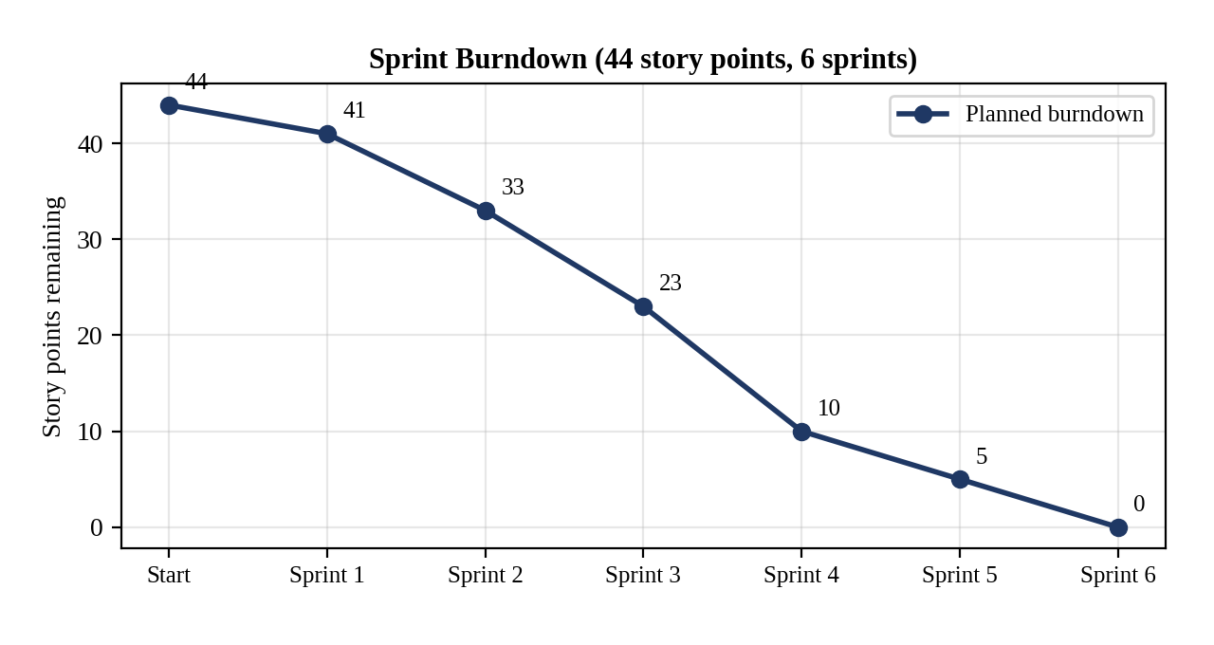
Figure 3: Planned sprint burndown chart

6. PROJECT DEVELOPMENT PHASE

Phase 1: Requirement Analysis and Planning
The goal of this phase was to define what the system must do and how it would be built. The system lets support users analyze the latest ticket of an account, classifies its priority from the description, creates tasks for urgent tickets, assigns a support level and returns a clear message through Agentforce.

Functional Scope
- Custom object Support Ticket Intelligence with fields for ticket details, priority, status, assigned agent and SLA risk.
- Relationships: lookups to Account, Contact and User, and Tasks related to the ticket.
- An Auto-Launched Flow for retrieval, keyword-based analysis, priority setting, task creation and assignment.
- An Agentforce subagent and a Flow-based action for conversational access.
- Profiles, roles and permission sets for user-level access.
- Reports and a dashboard for ticket priority and status insights.

Stakeholder Mapping
Stakeholder | Role in the System
Customers | Raise issues and expect quick resolution.
Support Agents | Handle tickets and need clear priority and assignment.
Support Managers | Monitor workload, ticket status and team performance.
AI Agent (Agentforce) | Automates analysis and triggers the required actions.

Execution Roadmap
- Developer org setup and custom object creation.
- Fields, relationships and validation rules .
- Auto-Launched Flow for priority analysis and task creation.
- Agentforce subagent and Flow-based action.
- Lightning record page, reports and dashboard.
- Data migration, security setup, testing and documentation.

Phase 2: Backend Development and Configurations
This phase built the working core of the system. Declarative tools (custom object, fields, validation rule and Flow) hold and process the ticket data, while Agentforce adds the conversational layer. Configuration and logic were created and tested step by step in the Developer org.

Milestone 1: Salesforce Developer Account
- Open the Salesforce Developer Edition sign-up page and enter your name, email, role (Developer), company (college name), country, postal code and a unique username in the form name@organization.com.
- Open the verification email, click Verify Account, set a password and answer the security question to reach the Setup home page.
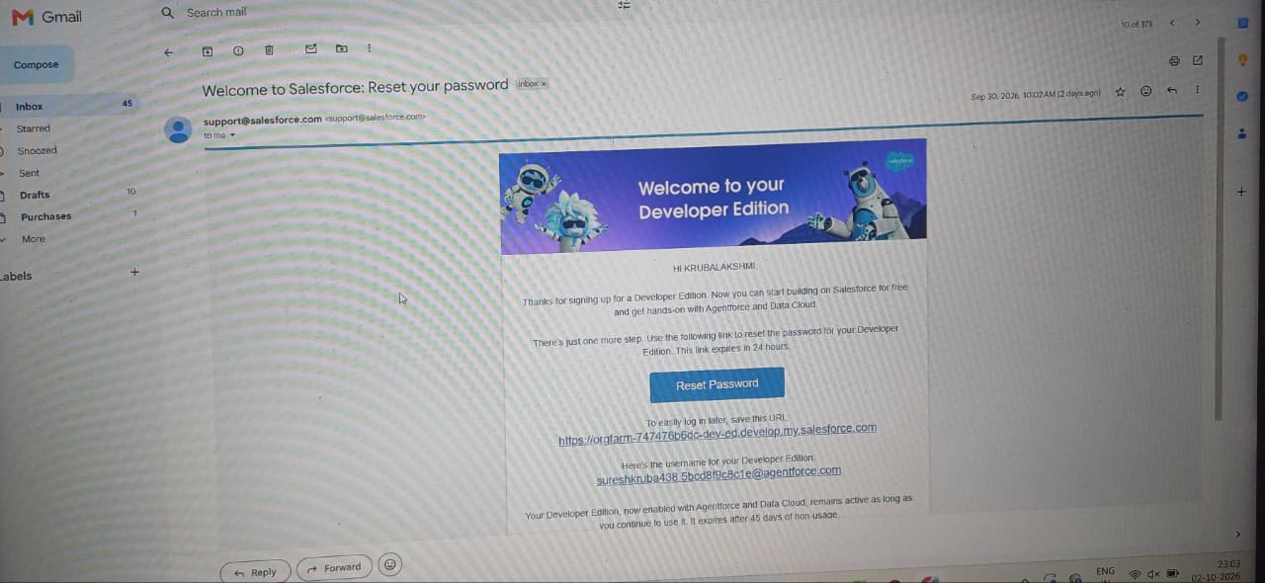

Milestone 2: Custom Object
An object is a database table that stores organization-specific data. The custom object was created from Setup → Object Manager → Create → Custom Object.
Object | API Name | Purpose
Support Ticket Intelligence | Support_Ticket_Intelligence__c | Stores each support ticket with its priority, status and assignment

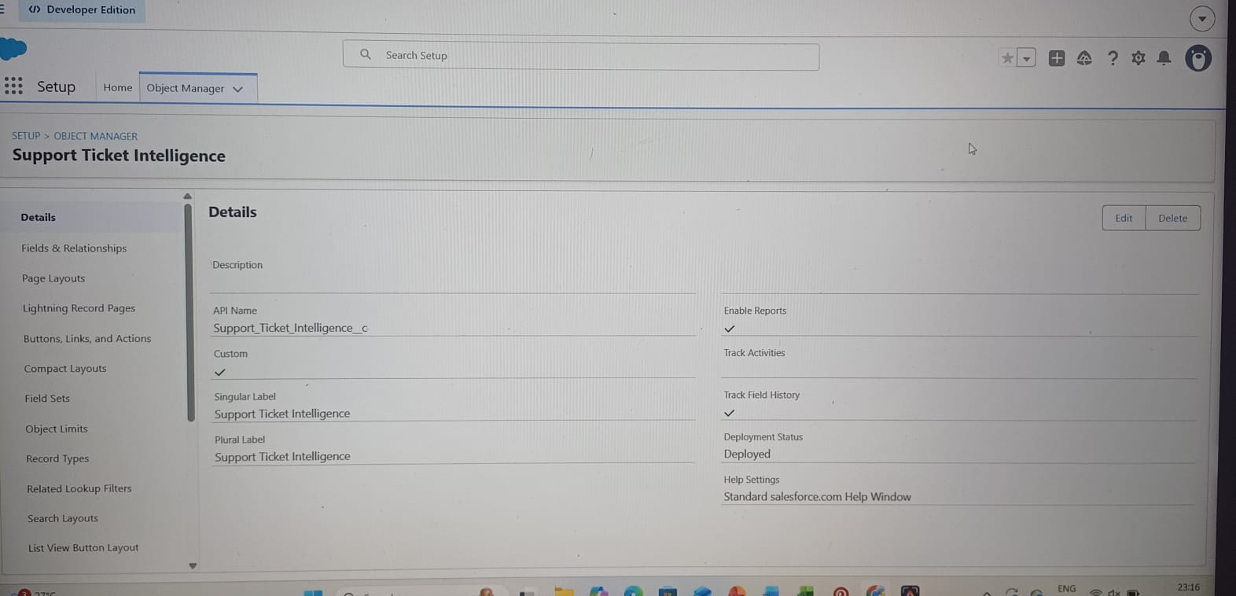

Milestone 3: Tab
A custom object tab was created for Support Ticket Intelligence (Setup → Tabs → New under Custom Object Tabs), with a tab style selected and the other options left at their defaults.
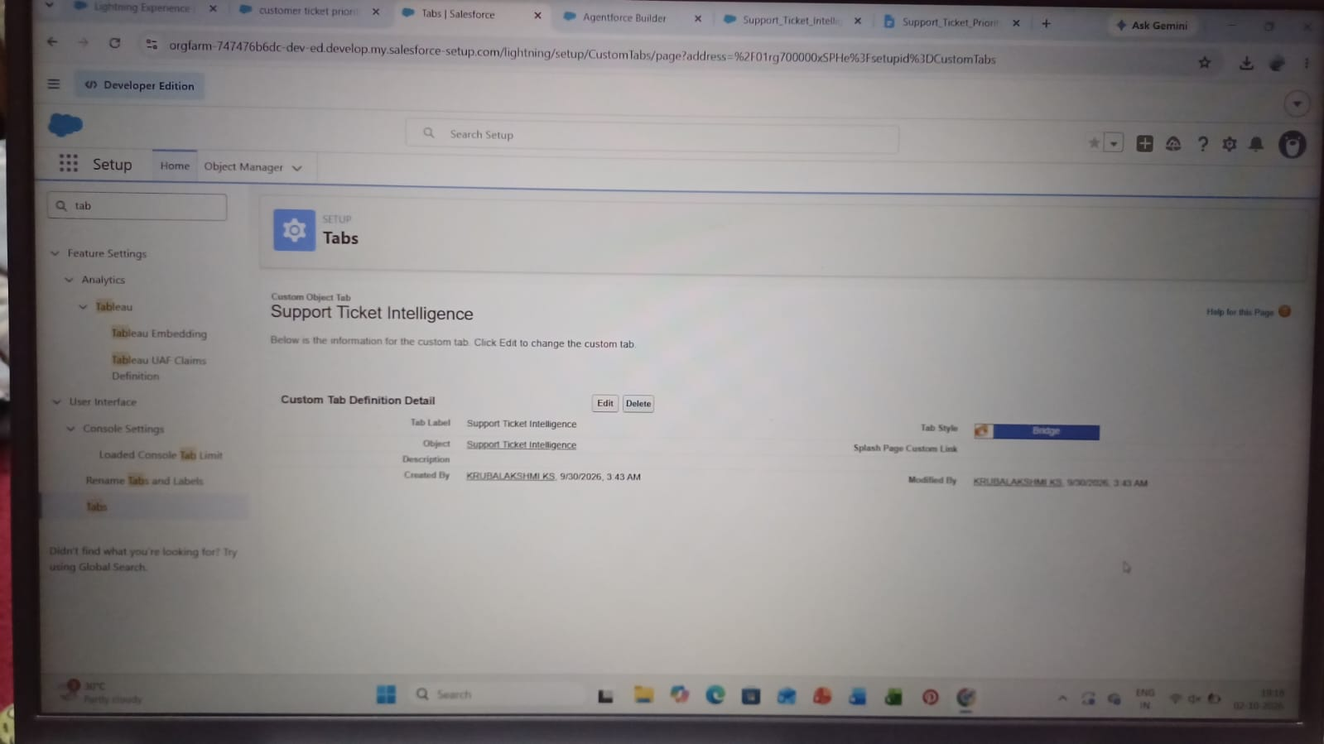

Milestone 4: Fields and Relationships
Standard fields exist on every object; custom fields were added to meet the business requirements.
Field Label | API Name | Data Type | Description / Values
Ticket Number | Ticket_Number__c | Auto Number | Format TKT-{0000}
Customer | Customer__c | Lookup (Account) | Related account
Contact | Contact__c | Lookup (Contact) | Customer contact
Issue Type | Issue_Type__c | Picklist | Technical, Billing, General
Description | Description__c | Long Text Area | Issue details
Priority Level | Priority_Level__c | Picklist | Low, Medium, High
Status | Status__c | Picklist | New, In Progress, Resolved
Created Date | Created_Date__c | Date | Ticket date
Assigned To | Assigned_To__c | Lookup (User) | Support agent
SLA Breach Risk | SLA_Breach_Risk__c | Checkbox | Risk flag
Resolution Time (hrs) | Resolution_Time__c | Number | Time taken

Relationships
Relationship | Type
Support Ticket Intelligence → Account (Customer) | Lookup
Support Ticket Intelligence → Contact | Lookup
Support Ticket Intelligence → User (Assigned To) | Lookup
Task → Support Ticket Intelligence (WhatId) | Related to (activity)
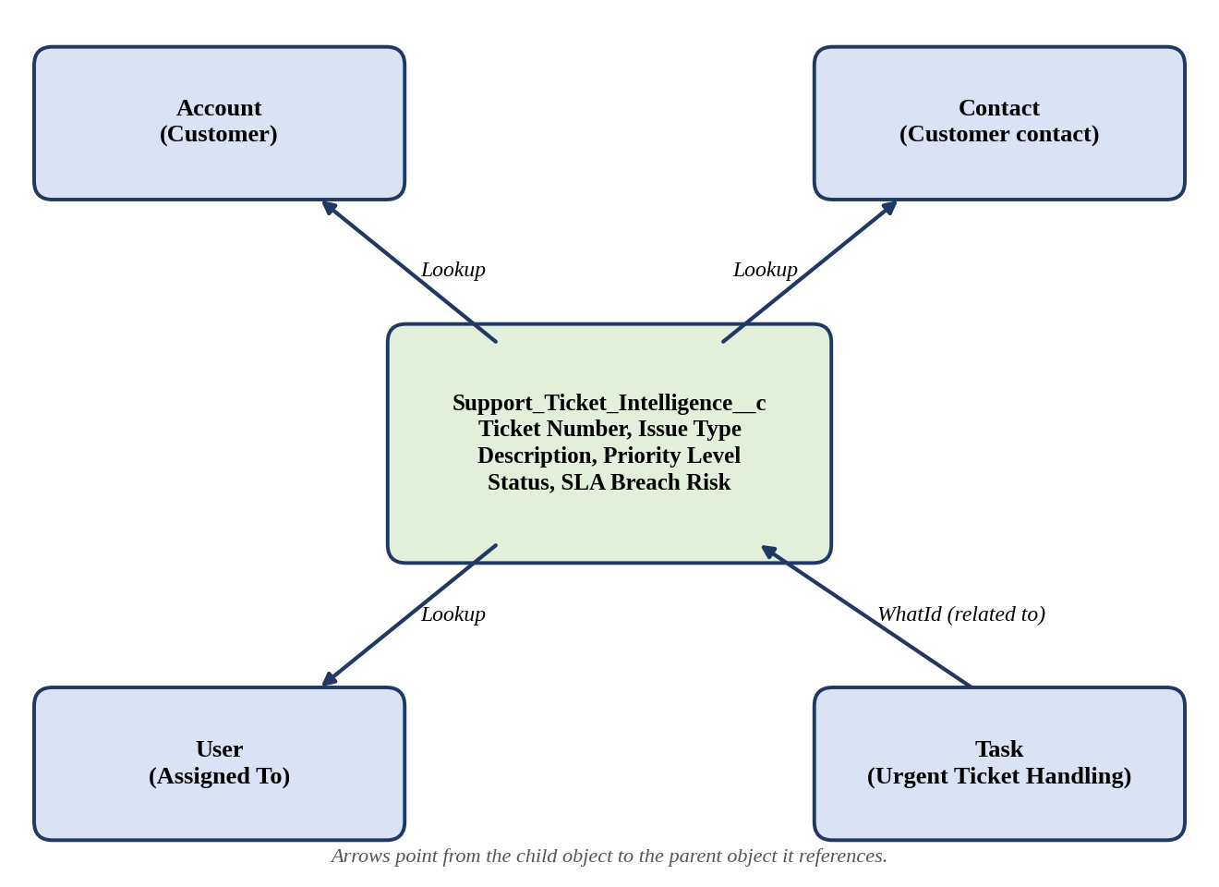
Figure 4: Data model: objects and relationships

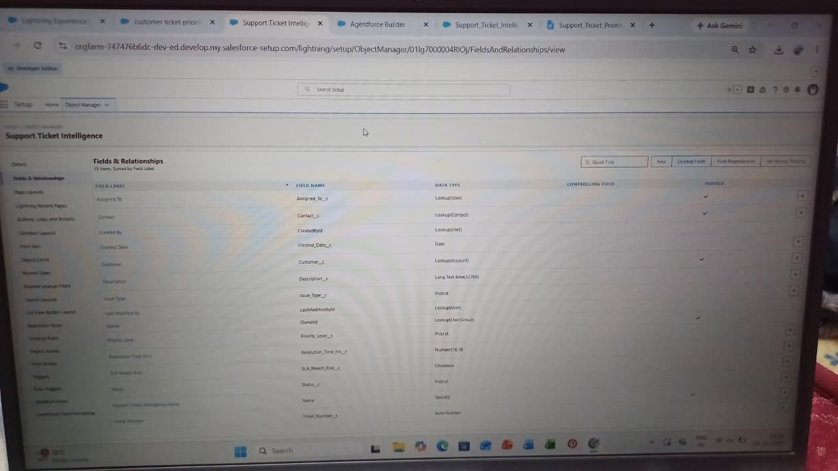

Milestone 5: Validation Rule
A validation rule checks data when a record is saved and stops the save if the condition is not met. The rule Description_Required was created on Support_Ticket_Intelligence__c so that every ticket carries a description for the priority analysis.
Rule Name: Description_Required
Active: Yes
Formula: ISBLANK(Description__c)
Message: Please enter the ticket description.
Location: Field → Description

Milestone 6: Auto-Launched Flow
Scenario: when the Flow receives an Account Name, it finds the latest ticket of that account, analyzes the description and sets the priority. For High priority it creates an urgent task and assigns a senior support agent. The Flow is called by the Agentforce action and has no trigger of its own.
Variable Label | API Name | Type | Direction
Account Name | varAccountName | Text | Input
Account Id | varAccountId | Text | Output
Ticket Id | varTicketId | Text | Output
Priority Level | varPriorityLevel | Text | Output
Assigned Agent | varAssignedTo | Text | Output
Action Message | varActionMessage | Text | Output

Step | Element | Label | Configuration
1 | Get Records | Get Account | Account where Name equals varAccountName; sort by CreatedDate descending; first record only.
2 | Assignment | Store Account Id | varAccountId = Get_Account.Id
3 | Get Records | Get Ticket | Support_Ticket_Intelligence__c where Customer__c equals varAccountId; latest first; first record only.
4 | Assignment | Store Ticket Id | varTicketId = Get_Ticket.Id
5 | Decision | Analyze Description | High: description contains urgent, not working or failure. Medium: contains issue, slow or delay. Default outcome: Low.
6 | Assignment | Set Priority Level | varPriorityLevel = High, Medium or Low on the matching path.
7 | Create Records | Create Task (High only) | Subject Urgent Ticket Handling; WhatId = varTicketId; Priority High; Status Not Started.
8 | Assignment | Set Assigned Agent | varAssignedTo = Senior Support Agent (High path).
9 | Decision | SLA Risk (optional) | Checks whether the ticket is older than two days.
10 | Assignment | Set Final Message | High: urgent ticket assigned to senior agent. Medium: will be handled shortly. Low: queued for processing.
11 | Save and Activate | Support_Ticket_Intelligence | Save the Flow and activate it.
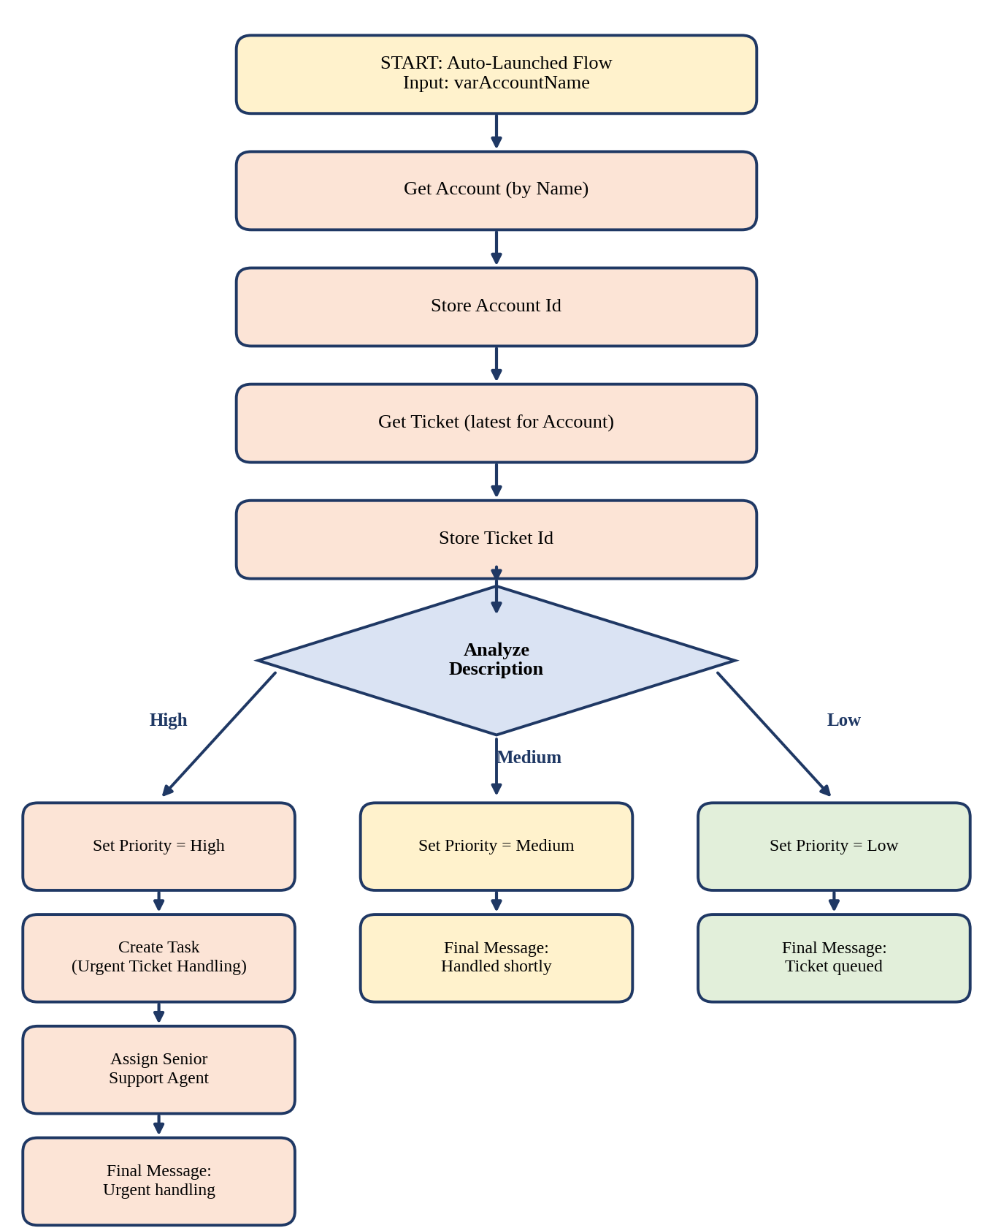
Figure 5: Auto-Launched Flow logic

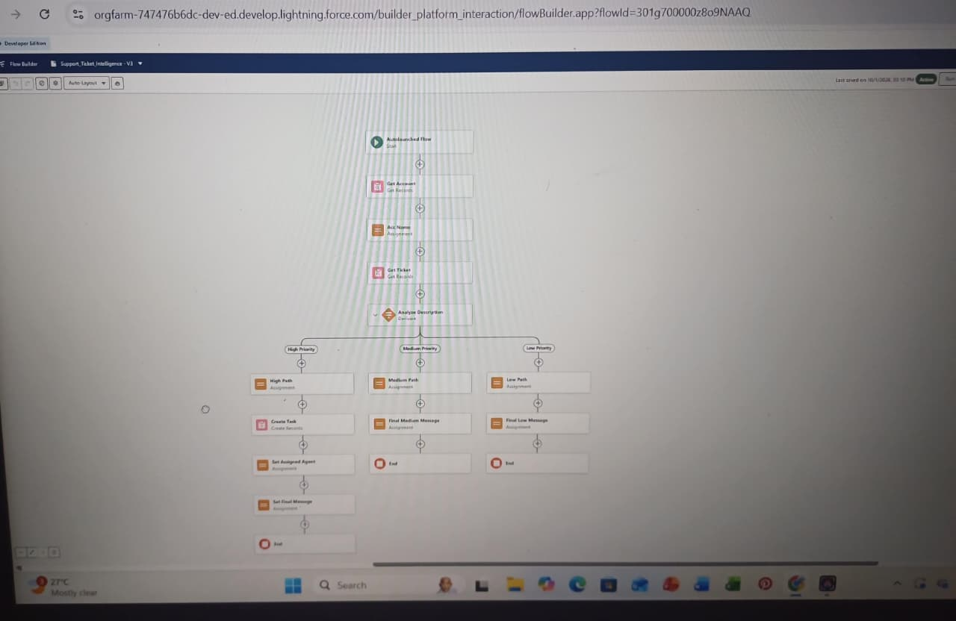

Milestone 7: Enabling Agentforce
- Click the gear icon and open Salesforce Go.
- Search for Agentforce (Default), select it and choose Get Started, then Turn On and Confirm.
- Search Agents in the Setup Quick Find box, make sure Agentforce is enabled, and open Agentforce (Default) in Builder.

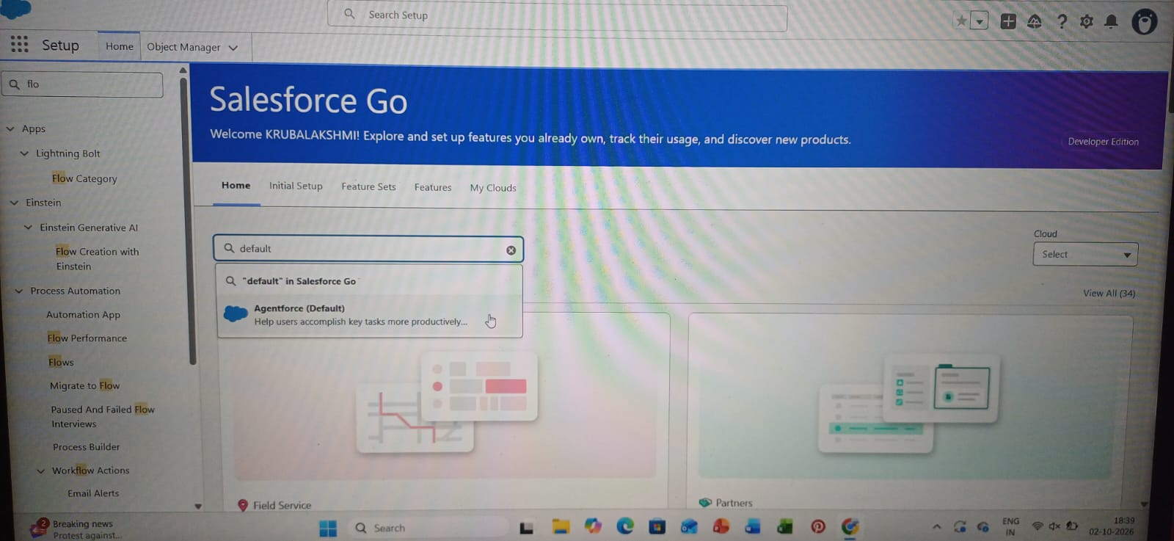

Milestone 8: Subagent Configuration
In Agentforce Builder, under Subagents, choose New → New Subagent and enter the details below.
Setting | Value
Name | Support Ticket Priority Analysis
API Name | Support_Ticket_Priority_Analysis
Classification Description | Analyzes customer support tickets to determine priority based on issue description and urgency; handles requests about ticket status, issue severity and support prioritization.
Scope | Only analyze support ticket descriptions, determine the priority level (High, Medium, Low) and trigger backend automation for task assignment. Do not handle billing, subscription management or account updates.

Instructions given to the subagent:
- Ask the user for the Account Name if it is not already given.
- Retrieve the latest support ticket associated with the Account.
- Read and analyze the ticket description.
- Determine priority: High if it contains urgent, not working or failure; Medium if it contains issue, slow or delay; otherwise Low.
- Set the priority level accordingly.
- For High priority, trigger the Auto-Launched Flow and ensure an urgent task is created.
- Assign the ticket to the appropriate support level, such as a senior agent for High priority.
- Return a clear message: High means urgent handling is initiated, Medium means it will be handled shortly, Low means it is queued.
- Do not update records directly or send emails; use the Flow for all actions.

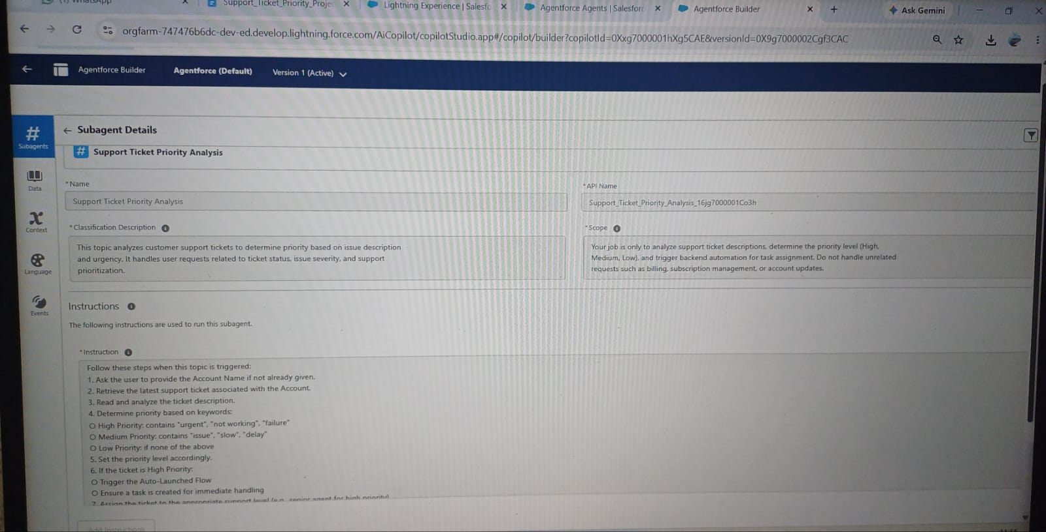

Milestone 9: Agent Action
Under This Topic's Actions, choose New → Create New Action, set the Reference Action Type to Flow and select the Support Ticket Intelligence Flow. Then configure the action as follows.
Action Field | Name | Description
Action Description | - | Analyzes support tickets for the provided account name, determines priority from the issue description and triggers automation for High-priority cases.
Loading Text | - | Analyzing ticket details and determining priority...
Input | varAccountName | Account name used to fetch the latest ticket (required; collected from the user).
Output | varAccountId | Unique ID of the account used for retrieval.
Output | varTicketId | Unique ID of the analyzed ticket.
Output | varPriorityLevel | Calculated priority: High, Medium or Low.
Output | varAssignedTo | Support agent or team assigned.
Output | varActionMessage | Final message describing priority and actions taken.
All outputs are set to Show in Conversation with Text rendering.
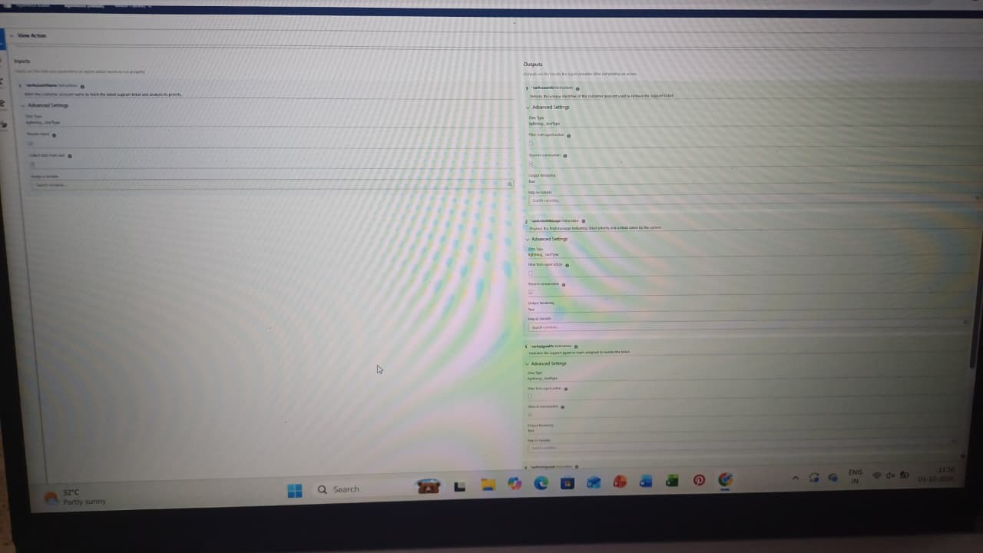

Phase 3: UI/UX Development and Customization
This phase gave users a simple workspace. Support users work with ticket records on a Lightning record page, interact with the Agentforce conversation panel, and view reports and a dashboard that turn ticket data into visual summaries.

Milestone 10: Lightning Record Page
The record page of Support Ticket Intelligence shows the customer, contact, issue type, description, priority level and status. The Activity timeline lists the Urgent Ticket Handling tasks created automatically by the Flow for High-priority tickets.

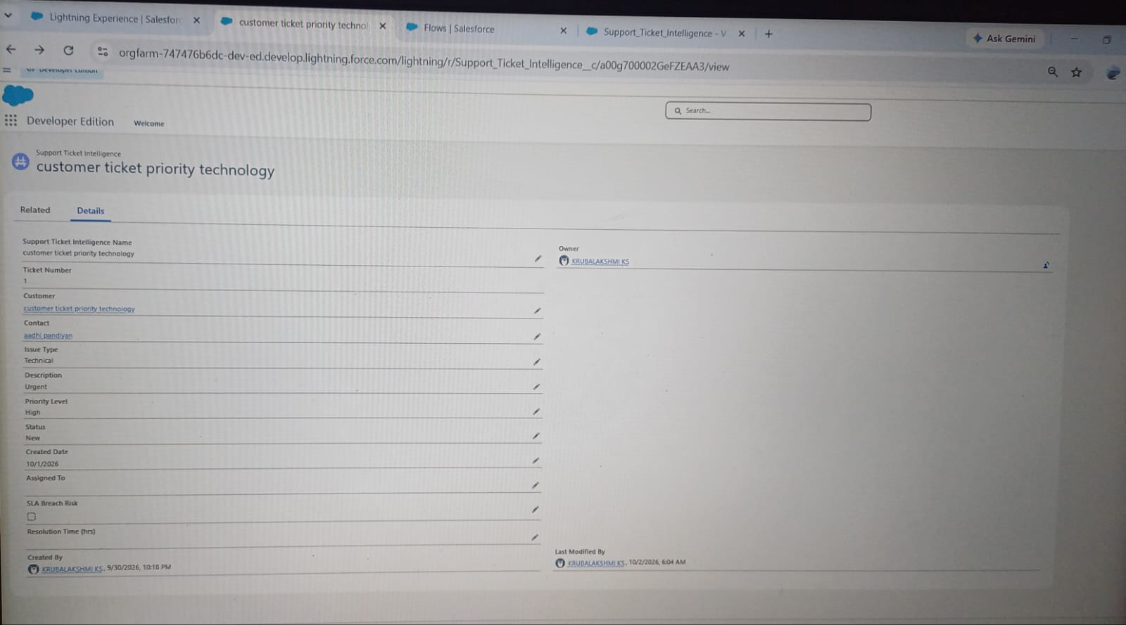

Milestone 11: Agentforce Conversation
Support users test and use the solution in the Conversation Preview. The agent asks for the Account Name, runs the action, and returns the ticket ID, priority, assigned agent and action message.

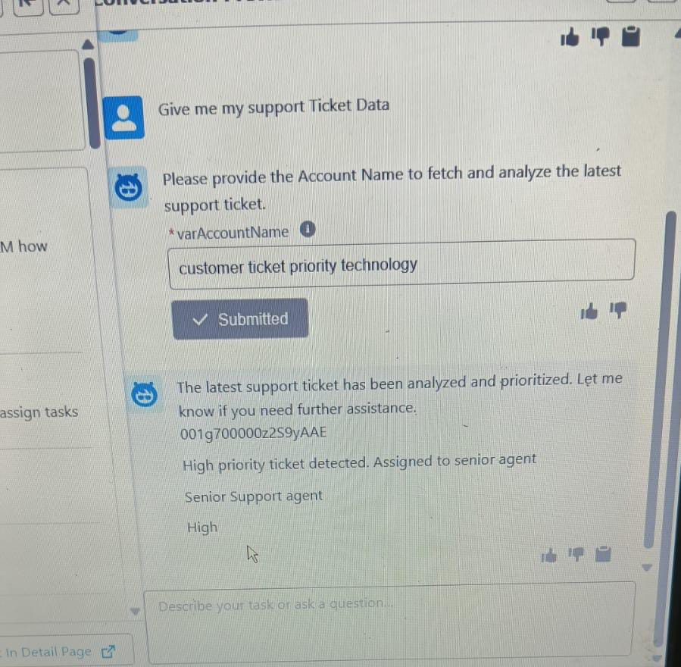

8. ADVANTAGES AND DISADVANTAGES

Advantages
- Automatic prioritization: tickets are classified as High, Medium or Low from their description.
- Faster handling of critical issues: agents focus on urgent tickets first.
- Reduced manual effort: analysis, priority setting, task creation and assignment are automated.
- Urgent task creation: High-priority tickets automatically get an Urgent Ticket Handling task.
- Better assignment: urgent tickets reach a senior support agent.
- Conversational support: users get results by chatting with Agentforce.
- SLA awareness: older unresolved tickets can be checked for breach risk.
- Scalability: Salesforce automation supports growing ticket volumes.
- Higher productivity: teams spend more time resolving and less time sorting.

Disadvantages
- Keyword-based logic: priority depends on configured keywords such as urgent, slow and delay.
- Limited context understanding: some urgency signals may be missed because the logic uses fixed conditions.
- Dependence on data quality: correct Account, Contact and ticket data is needed.
- Configuration dependency: the Flow and the subagent instructions must be maintained properly.
- Limited scope: the subagent handles only ticket analysis, not billing or subscriptions.
- Basic SLA monitoring: the SLA check is optional and not a full escalation solution.
- Developer Edition limits: the project was built for academic purposes and is not deployed to production.
- Limited analytics: advanced trend analysis is part of future scope.

9. CONCLUSION
The Customer Support Ticket Priority Prediction and Automated Assignment System shows how Salesforce Flow and Agentforce can work together to reduce manual ticket handling. The solution retrieves the latest ticket for an Account, analyzes its description, classifies priority, creates an urgent task for High-priority cases, assigns a support level and returns a clear conversational response.
Building the project covered the full implementation cycle: designing a data model, writing a validation rule and a Flow, configuring an Agentforce subagent and action, securing data with profiles, roles, permission sets and sharing settings, migrating data, testing and documenting the result. Although the solution was built and tested in a Developer Edition org without a production deployment, it follows real-world Salesforce practice and provides a base for future growth.

10. FUTURE SCOPE
- Add more priority indicators and business rules, including sentiment analysis.
- Extend Agentforce outputs with additional ticket information.
- Add advanced SLA monitoring with escalation and notifications.
- Support more teams, skills and workload-based assignment through Omni-Channel.
- Introduce analytics for priority trends and resolution performance.
- Suggest automatic replies to customers.
- Production deployment using sandboxes, change sets or Salesforce DX.

11. APPENDIX
- A. Custom Object: Support Ticket Intelligence (Support_Ticket_Intelligence__c).
- B. Key Salesforce Records: Account, Contact, User and Task.
- C. Automation: Support_Ticket_Intelligence Auto-Launched Flow and the Description_Required validation rule.
- D. Agentforce: Support Ticket Priority Analysis subagent and the Flow-based Support Ticket Intelligence action.
- E. Security: Profiles, role hierarchy, Ticket Automation Access permission set and sharing settings.
- F. Analytics: Tickets by Priority report and Support Operations Dashboard.

